**Abstract**

Password cracking is the process system .

Dictionary Attack

* Brute Force Attack and
* Guessing techniques, etc.

**Introduction**

Today, most people use passwords to protect encrypted passwords.

**Objectives**

* To help
* passwords

**Motivation**



**What is Password?**

* Mobile phones, and your life.

**What is password cracking?**

* .

**Benefits of Password Cracking**

**Types of Password Attacks**

* Dictionary Attack
* Brute Force Attack
* Rainbow Table Attack
* Phishing
* Social Engineering
* Malware
* Offline Cracking
* Guess

**Password Cracking Depends on**

* ,

**Password Cracking Tools**

* Brutus
* RainbowCrack
* Wfuzz
* John the Ripper
* THC Hydra
* Medusa
* AirCrack-NG
* OphCrack
* LophtCrack

**Implementation**

**Cracking Linux User Password**

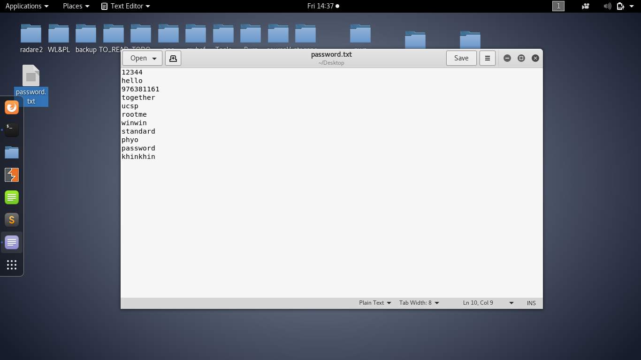

**Fig1.Creating Wordlist**

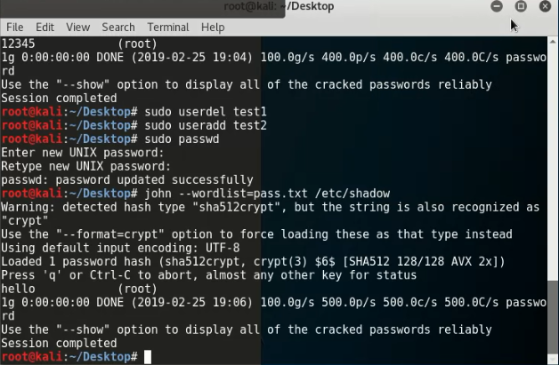

**Fig2. Cracking Linux User Password Code**

**Cracking Password Protected ZIP Files**

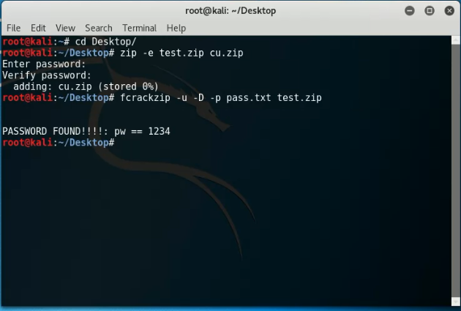

**Fig3. Cracking ZIP Files Password Code**

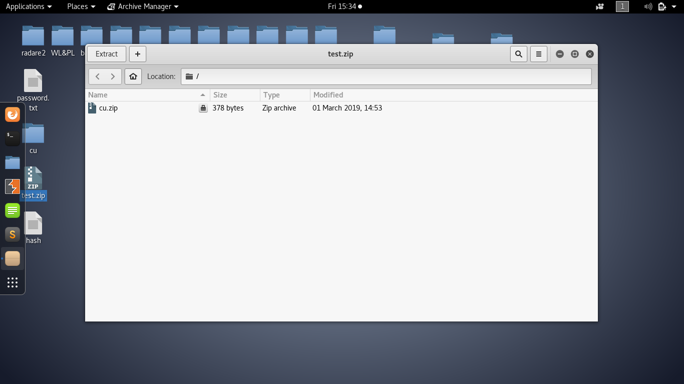

**Fig4. ZIP Files With Password**

**Decrypting MD5 Hash**

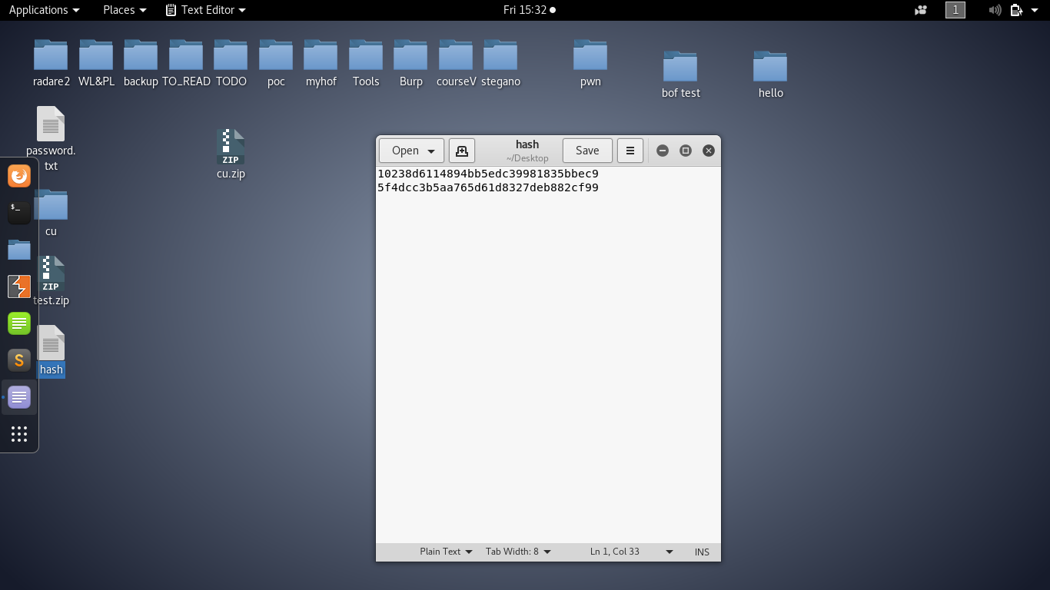

**Fig5.Hash File**

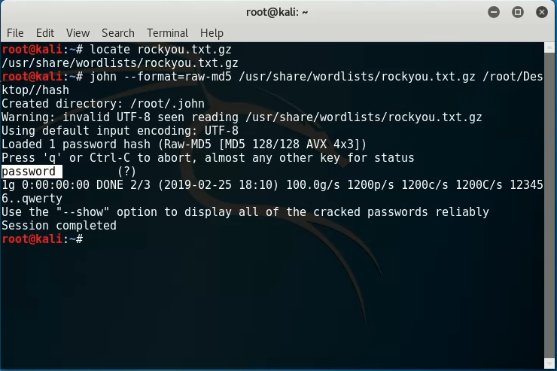

**Fig6. Decrypting MD5 Hash Code**

**Strong Password**

* Consists of at least six characters
* Letters, (@, #, %, $, etc…)
* password
* Do not
* own name.

**Conclusion**

* Many depend on secret passwords.
* The length remain fixed over time.
* Hardware.
* As a result,.